Physics Lab #8: LCR Circuits and the Speed of Light
Charlie Coleman
Lab Partners: Alex Bielewicz, Tracey Jaron
2016 October 26

Abstract: In part one of the lab, the objective was to examine the behavior of various LCR circuits. In part two, the objective was to measure the phase velocity of light through a fiber optic cable in order to find the index of refraction. By using the given equations for the circuits built, the resonance frequency of the circuits could be found and compared to the measured values. In part two, the properties of light allow for light to be totally reflected when the index of refraction that the light is propogated through is great enough compared to the index of refraction outside. The lab was a success, as the values measured were approximately the values calculated. Part two of the lab had no measurement for failure, but the value found was reasonable.

Theory: The combination of inductors, capacitors, and resistors can be used to make frequency filters, to only allow certain frequencies through.

For the second part of the lab, a beam of light will reflect if the index of refraction of the material containing the beam is higher than the index of refraction of the surrounding material. When the angle of incidence is greater than asin(n0/ni), the light totally reflects and the light can be guided by the fiber. To check that the light is totally reflected, the speed of the light can be measured by a special board.

Objective: The objective of the first lab was to examine the behavior of different LCR circuits. In the second lab, the objective was to measure the speed of light through a fiber optic cable to find the index of refraction of the cable.

Procedure: For part one, the circuit was assembled as shown in the lab manual. Various frequencies are tested above and below the resonant frequency. The frequency, the input and the output voltages are recorded.

For part two, the box used to test the traversal of the light beam is calibrated. When the delay is canceled out, the delay of the 20m coil of cable is tested, and the time difference between input and output is recorded. This number can be used to measure the index of refraction.

Setup:
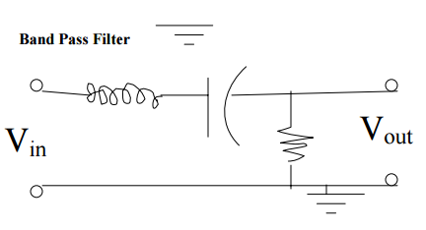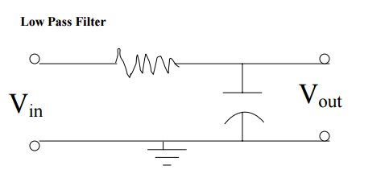

Data:
Constants

Low Pass Band Pass

Part Two:
dt (s): 1.03x10^-7

Calculations:
Part one:
ln f:
v0/vi:
Resonant Frequency (Low Pass):

Resonant Frequency (Band Pass):

Part two:
Speed of light through the fiber optic cable:

Index of refraction:

Qualitative Error Analysis: One error in this lab was the difficulty in measuring the peak to trough voltage of the inputs and outputs. Because the gridlines were so far apart, it was difficult to estimate the values. In the second part, one error is the difficulty in calibrating the board. It was difficult to tell the peak of the output waveform as it was more spread out than the input.

Quantitative Error Analysis:
Part one:

Results:
Low Pass: Band Pass:

Part two:
Phase Velocity: 2.136x10^8 m/s
Index of Refraction: 1.40

Conclusion: In part one of this lab, the behavior of multiple LCR circuits were tested and examined. In part two, the phase velocity of light through a fiber optic cable was measured. This lab was a success because the values found in part one of the lab were approximately equal to the calculated values. No test for success was given for part two of the lab, but the value for the index of refraction in the fiber optic cable was within a reasonable range. One reason for the error in this lab was the impercise measurement of voltage on the oscilascope, because the gridlines were so far apart.

